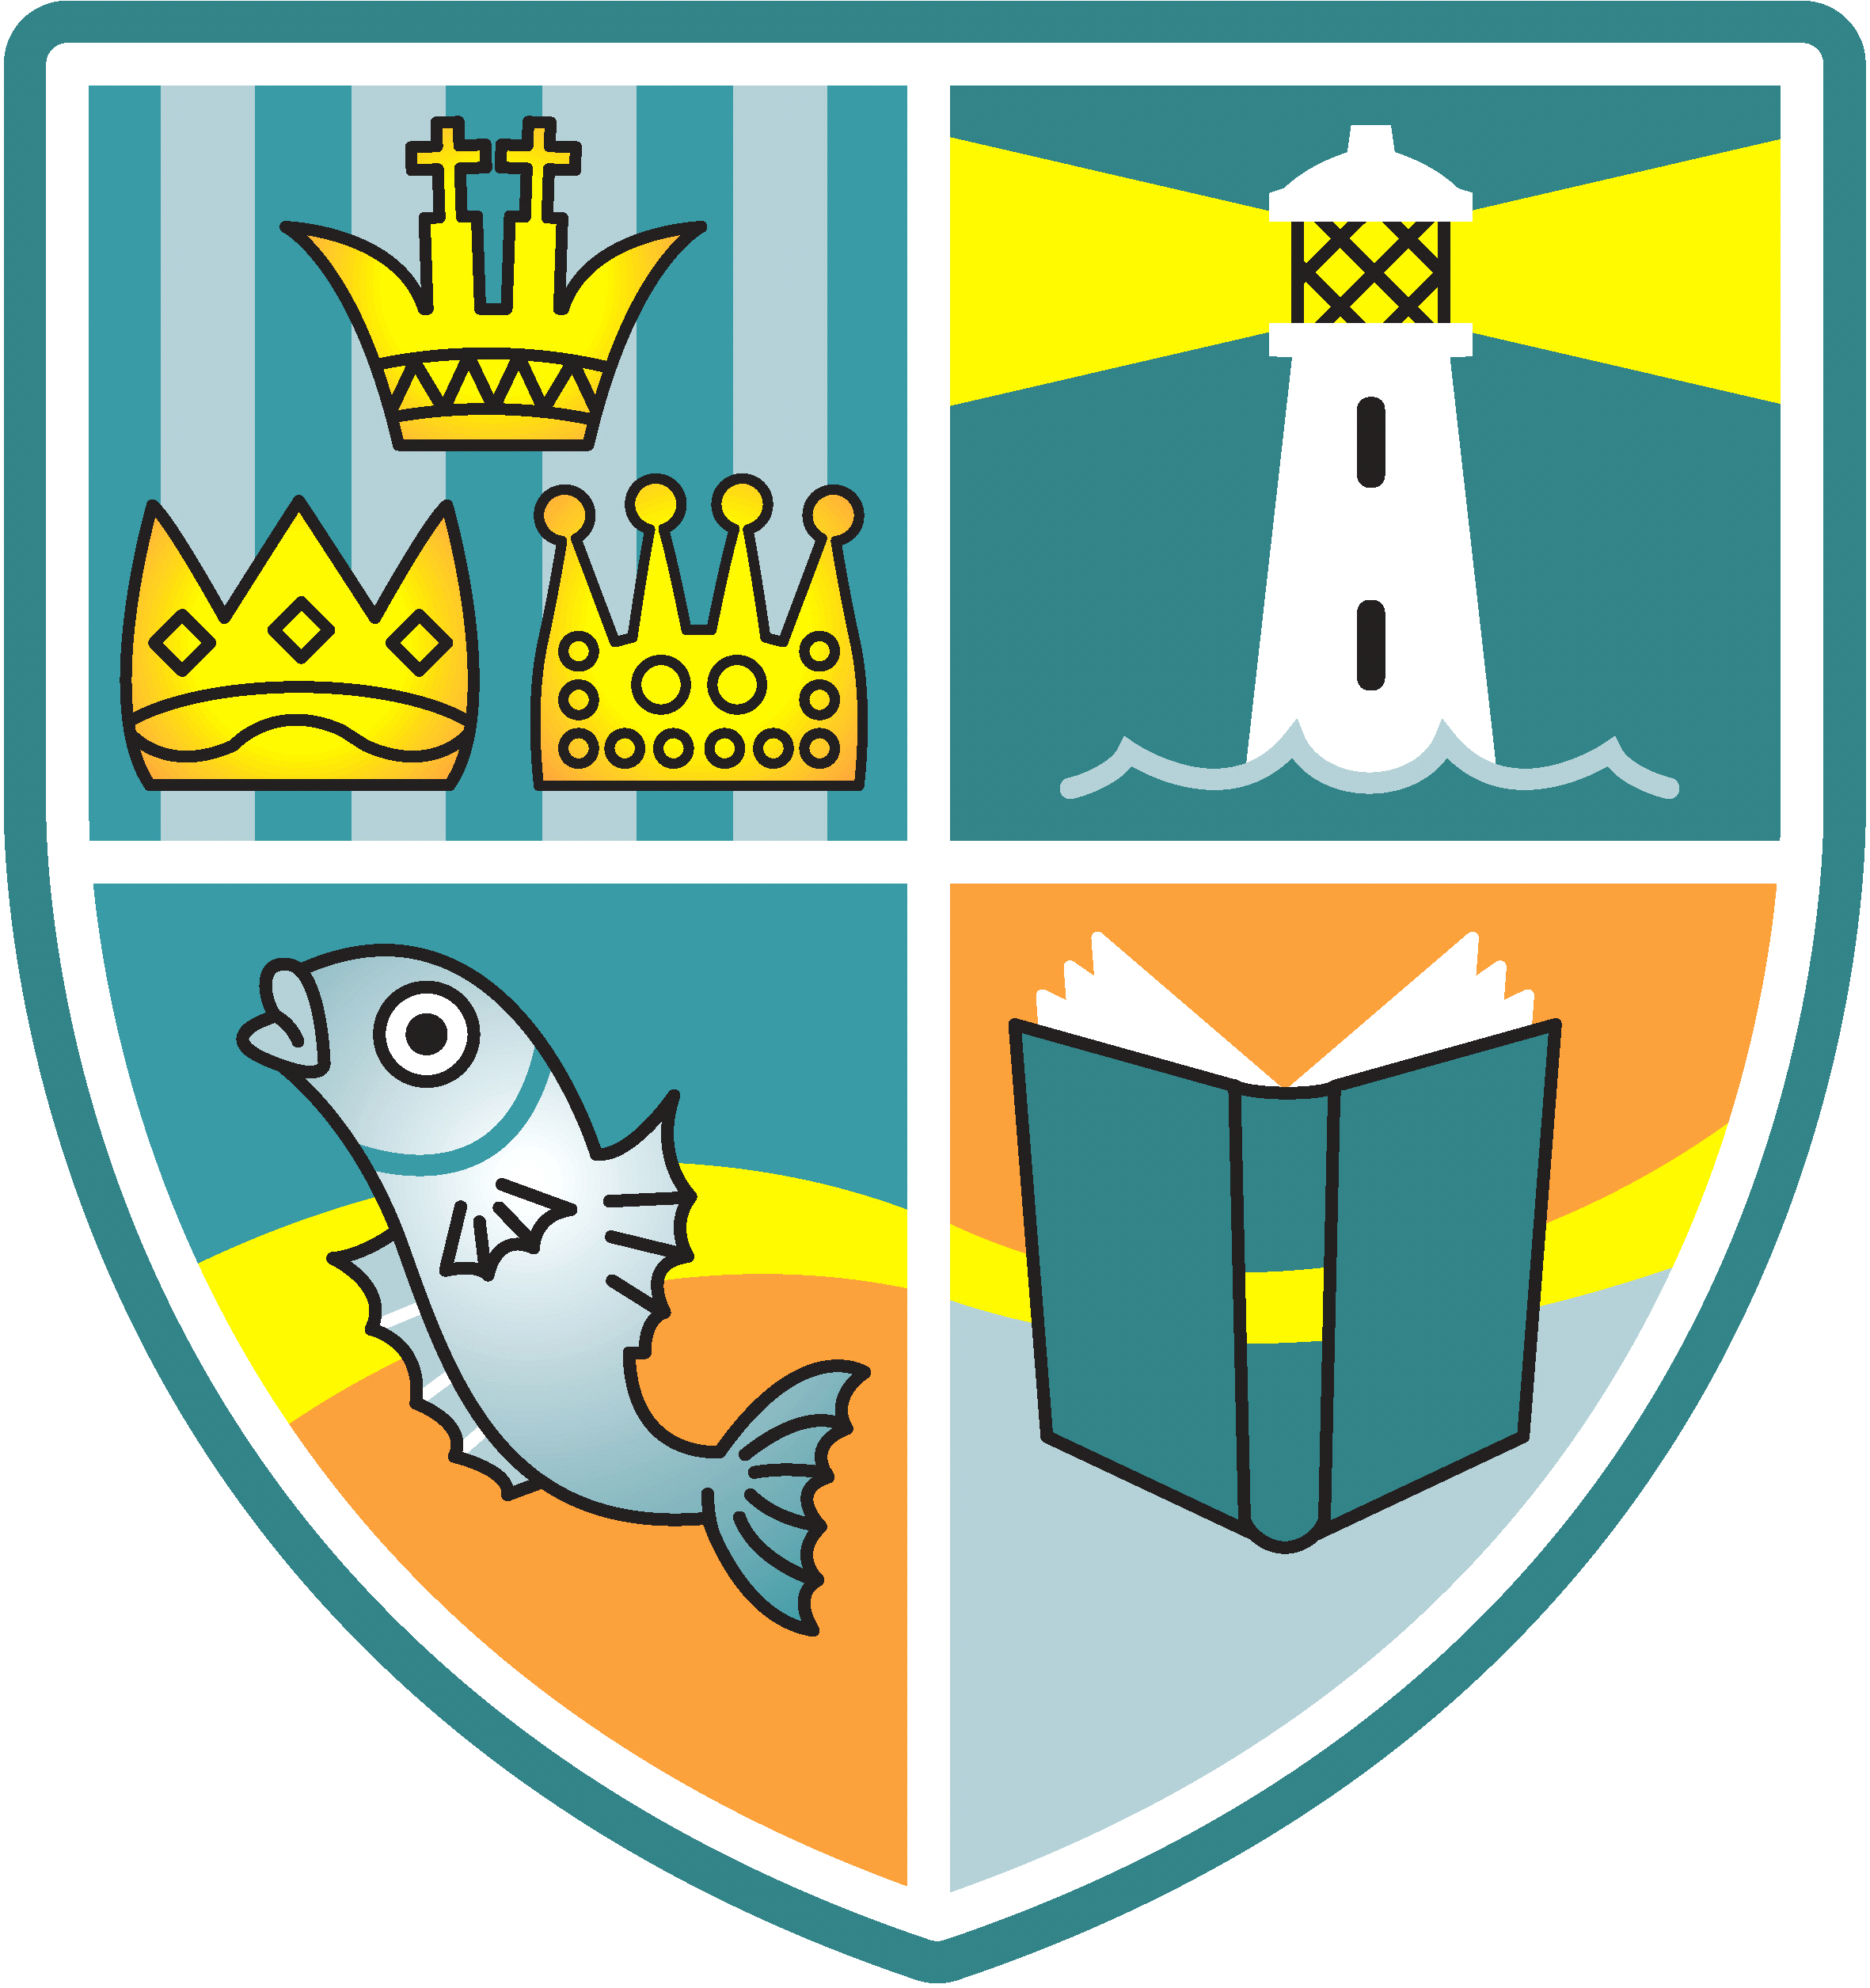
Whitehouse Newsletter
9th October 2020
School Details: Tel: 0191 643 2890 Headteacher: Ms R Woods
Twitter:@whitehouseps Email: office@whitehouseprimary.org.uk Website:whitehouseprimary.org.uk

Thank-you
Thank-you to all our families who have adhered to the staggered start and finish times each day. This has really helped to keep our school environment safe and to keep adults socially distanced. We constantly refine our procedures and Risk assessments to keep our school as Covid- safe as we can, but this does rely on our families following the local regulations very strictly too. We are hearing of a few ‘sleepovers’ between houses which then increases the risk of infection. You may only go inside the house of a single person (e.g. grandparent) who you are in a ‘support bubble’ with. Please ensure that you take this as seriously as we do in school. However, I am really happy to report that the behaviour, the work ethic and the renewed kindness demonstrated by the vast majority of our pupils has been commented upon by staff. The school remains a calm and happy place for your children to learn and thrive in each day, during these challenging times.
Remote Learning
If your child’s class has to isolate for 14 days or that your have another member of your family sent home due to an outbreak, we need you all to be ready for our remote learning to click into place. We have secured a number of laptops for any family who may have to continue to learn at home and who don’t have any form of IT at home. These would be loaned out to anyone who needed one temporarily. Agreements for the care and prompt return of any IT equipment would have to be signed by the parent. We are also looking into leasing some Ipads to support home learning, where they are needed.
SeeSaw/Tapestry
These are the two Apps that we use in school to communicate and share work between home and school. The vast majority of our families have signed up and use it successfully. Please contact school if you do not access or a code.
Harvest/Nite Bite
We will not be able to run our usual Harvest Festival this year, due to current guidelines. However, we would still like to support our local charities; Nite Bite and the Bay Food Bank. If you have any tins, packets, jars of food that you are able to donate to these worthwhile causes, we will put a collection crate at the KS1 and KS2 gate each morning for you to drop off any donations in, from Monday 12th October. The last collection will be Thurs 22nd Oct. Thank-you for your kindness.
Reports
We usually have an introductory Parents Evening this term. However, things are different this year. We will be sending a short, written report home on Fri 11th December. In the meantime, feel free to contact your child’s class teacher through seesaw, Tapestry or email.
Christmas
You will be receiving a Christmas card that your child has made in school before October half term. If you wish to order a published set of cards of your child’s designs, please return to school with your order.
We are currently looking, as a staff team, at how we can safely celebrate Christmas this year and will inform you once decisions have been made.
Flu Immunisation Programme.
The School Nurses will be in school on Friday 20th November. There is a whole school flu immunisation programme this year which is a quick nasal shot. If you haven’t already done so, please return the consent/withdrawal form to the immunisation team this was posted out to your homes during the summer holidays with a freepost reply envelope. If you have lost this form, please contact the school office for a duplicate form to be emailed to you. The vaccine is a live vaccine and the nurses can only order enough for the children that they know about.

