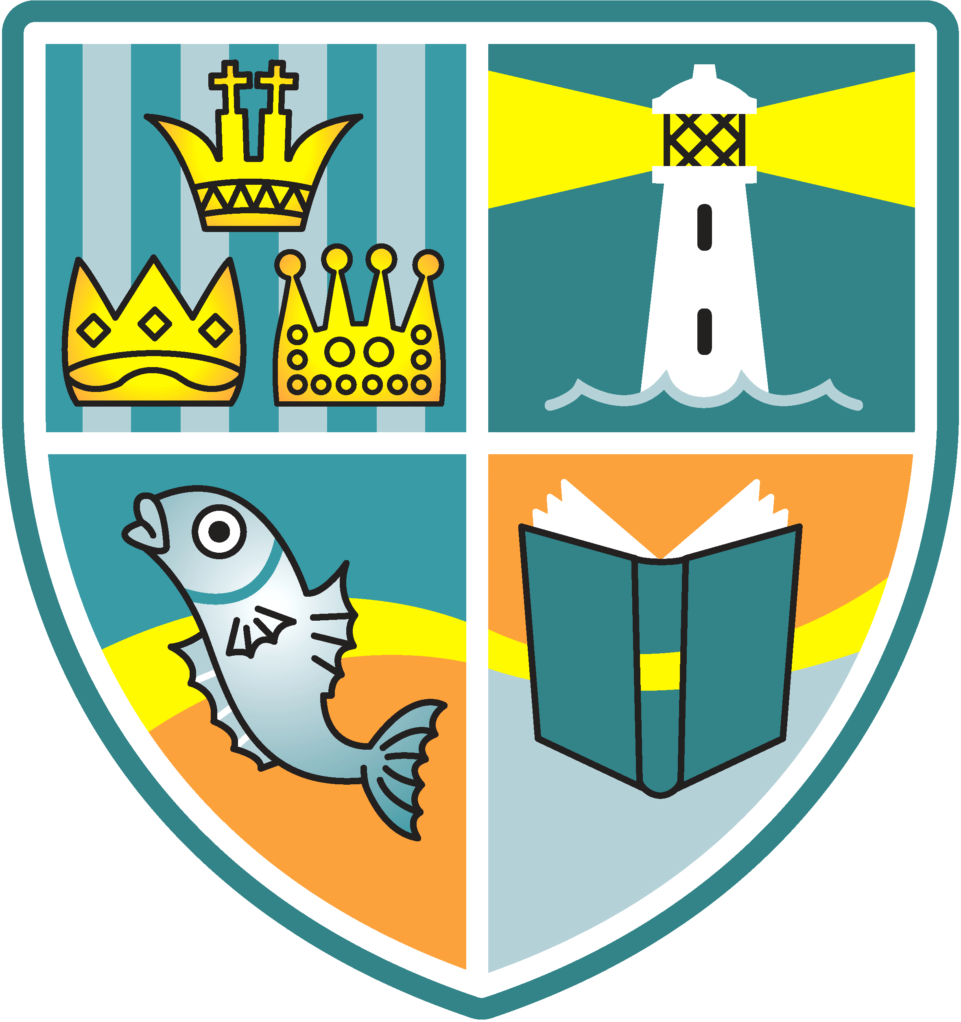
Whitehouse Newsletter
11th September 2020
School Details: Tel: 0191 643 2890 Headteacher: Ms R Woods
Twitter:@whitehouseps Email: office@whitehouseprimary.org.uk Website:whitehouseprimary.org.uk

Fantastic Attendance and Behaviour
The vast majority of classes have had 100% attendance since the start of the school year. I can only repeat that it so wonderful to see such a calm, happy and well-behaved school full of children.
Yet again, I want to thank all our parents/carers for using the ‘Park and Stride’ recommended approach to and from school. We have ‘marshalled’ the entrance roads on a daily basis and have been so impressed by everyone’s adherence to the rules and, more importantly, seeing everyone’s happy faces makes it worth it!

Remember, if your child is absent from school you must phone the school office on 0191 643 2890 to leave a message. Please be specific about your child’s symptoms, don’t just say unwell. We may need to phone you back.
Staffing /Contact Information
We will be sending out class contact information with photographs of your child’s teacher, support staff and details of how to contact them next week. We are aware that you don’t get to see all our staff under the new restrictions and we also have admitted several new families to our school this term, so it is also a big hello from us to you! Please keep this contact information safe for future use.
Here We Are
We will be creating a whole school display following our Recovery topic and will Tweet photographs soon @whitehouseps. It has been a rewarding experience to hear of the highs and lows of lockdown for our individuals, as we move forward on our journey through these new times.
School Lunches
From next week there will be an additional choice to the menus of a cold sandwich. The sandwich choice next week will be cheese.
Reminder - our school kitchens can provide a FREE cold/sandwich-based lunch OR a hotbox lunch for all Y2, Y1 and Reception children. This is under the Universal Infant Free School Meals scheme.
Save yourselves time and money by allowing the school to provide with a free lunch. As part of our Covid-19 Risk Assessment, we would like to see as few lunch boxes and bags coming to school as possible. This is part of government guidelines. Children, ideally, should just be bringing a clean water bottle.
Covid-19 Update
I hope you all received your copy of our Parent School Contract last week as this highlights the absolutely rigorous system of controls we have in place in school. Our ‘Bubbles’ are each class and are no larger. Some schools may be operating key stage bubbles, but we are keeping ours as limited and small as possible. We also have enhanced hygiene systems and have re-organised the whole school layout, with floor distance markers and a one-way system. Many parents have asked me about local Covid outbreaks starting to happen in schools in North Tyneside. Can I remind any parent that if you, your family or your child displays any of the symptoms, you must isolate immediately and engage in the Test, Track and Trace process and isolate for at least 10 days. The PHE would inform the school and separate bubbles would have to be risk assessed with the PHE team. I am in regular contact with the Director of Public Health and we have been informed that local cases are rising, so I would ask that all our Whitehouse families stay safe and observe social distancing and follow current guidelines, including gatherings of no more than 6 (from Monday).
Remember that if you need to book a test, log onto the NHS website – www.nhs.uk to take a test at a test site or with a home test kit. Tests are available via the following options (currently):
- On-line
- Drive Through
- Walk-in at the Molineux Centre, Byker or Newcastle General Hospital
- Home Test
There are currently plans for two walk-in sites in North Tyneside one in North Shields and the other in Wallsend.
Stay Safe everyone and have a great weekend. Thank-you to the many parents I have spoken to that have said that they feel safe and that the school is doing everything we can to make a ‘Covid-Secure’ environment for all our children, so that they can learn and grow safely. We appreciate your feedback.
Data sheets
It is very important that we have up-to-date information for your child. Please return the admission form as soon as possible.
High School and Reception Places for September 2021
The application round for school admissions in September 2021 is now open. You need to apply online at:
www.northtyneside.gov.uk
The closing dates are the 31st October for High Schools and the 15th January for Reception class.

